**STUDENT NAME – ABHISHEK SINGH**

**PROJECT NAME – MOVIE_INFO**

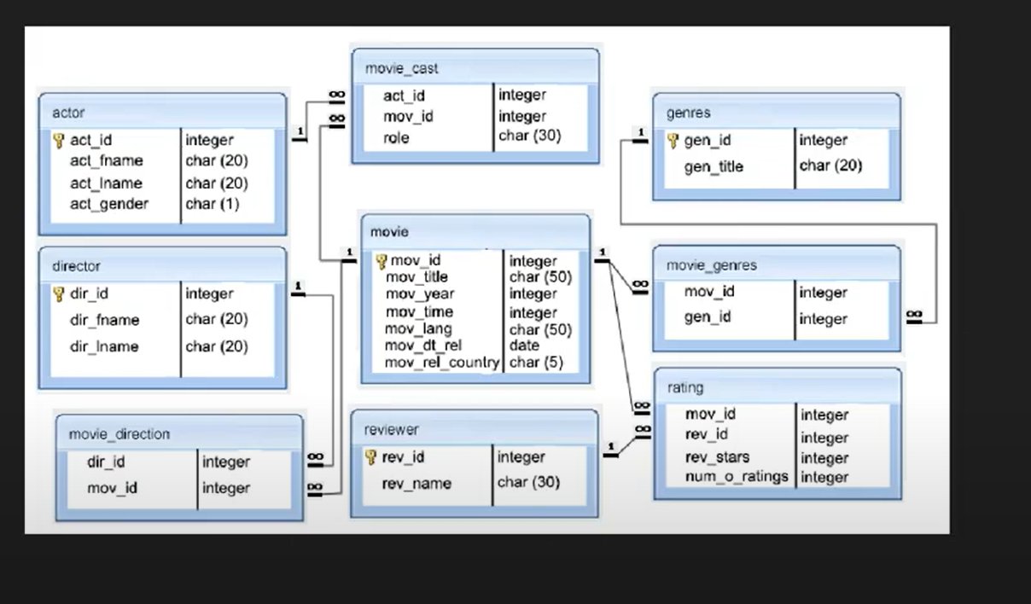

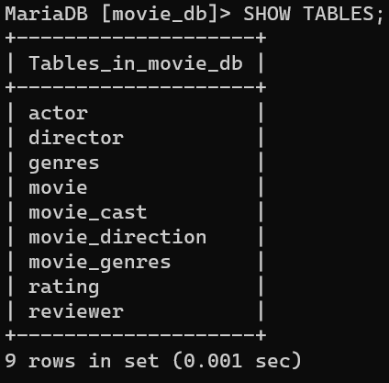

MariaDB [(none)]> create database movie_db;

Query OK, 1 row affected (0.001 sec)

MariaDB [(none)]> use movie_db;

Database changed

MariaDB [movie_db]> create table movie(

-> mov_id int primary key auto_increment,

-> mov_title varchar(50) not null,

-> mov_year int not null,

-> movie_time varchar(20) not null,

-> mov_lang varchar(50),

-> mov_dt_rel date,

-> mov_rel_country varchar(50));

Query OK, 0 rows affected (0.021 sec)

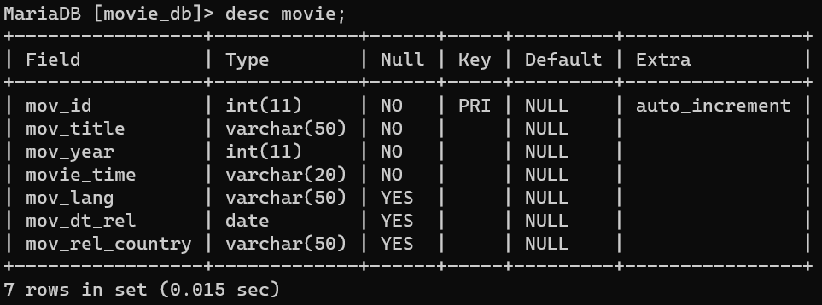

MariaDB [movie_db]> insert into movie values(1,"SWADES",2004,"3hr 9min","HINDI","2004-12-17","INDIA");

Query OK, 1 row affected (0.003 sec)

MariaDB [movie_db]> insert into movie values(2,"3 IDIOTS",2009,"2hr 50min","HINDI","2009-12-25","INDIA");

Query OK, 1 row affected (0.005 sec)

MariaDB [movie_db]> insert into movie values(3,"THE MARTIAN",2015,"2hr 21min","ENGLISH","2015-10-02","USA");

Query OK, 1 row affected (0.004 sec)

MariaDB [movie_db]> insert into movie values(4,"MISSION IMPOSSIBLE FALLOUT",2018,"2hr 43min","ENGLISH","2018-07-27","USA");

Query OK, 1 row affected (0.003 sec)

MariaDB [movie_db]> insert into movie values(5,"KANTARA",2022,"2hr 28min","KANNADA","2022-09-30","INDIA");

Query OK, 1 row affected (0.004 sec)

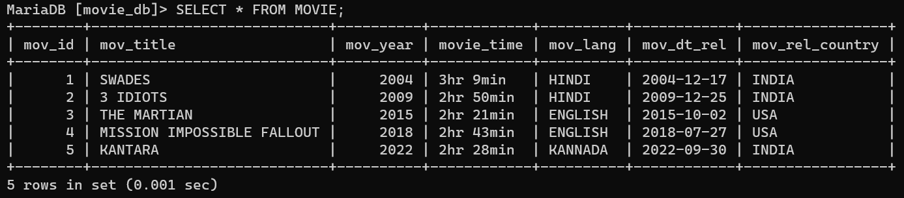

MariaDB [movie_db]> create table actor(

-> act_id int primary key auto_increment,

-> act_fname varchar(20) not null,

-> act_lname varchar(20) not null,

-> act_gender enum("M","F"));

Query OK, 0 rows affected (0.014 sec)

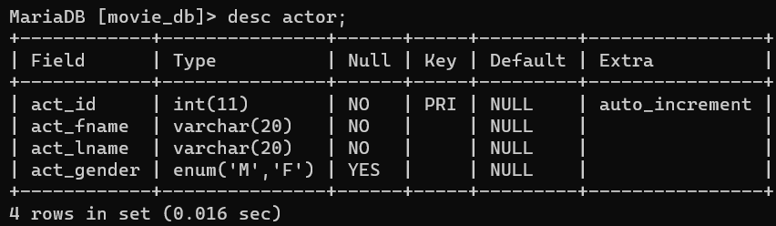

MariaDB [movie_db]> insert into actor values(101,"SHAHRUKH","KHAN","M"),

-> (102,"AAMIR","KHAN","M"),

-> (103,"MATT","DAMON","M"),

-> (104,"TOM","CRUISE","M"),

-> (105,"RISHAB","SHETTY","M");

Query OK, 5 rows affected (0.004 sec)

Records: 5 Duplicates: 0 Warnings: 0

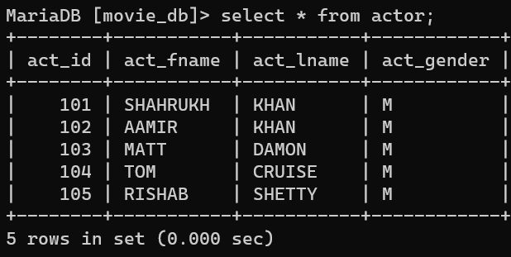

MariaDB [movie_db]> create table movie_cast(

-> act_id int,

-> mov_id int,

-> role varchar(20),

-> foreign key(act_id) references actor(act_id),

-> foreign key(mov_id) references movie(mov_id));

Query OK, 0 rows affected (0.035 sec)

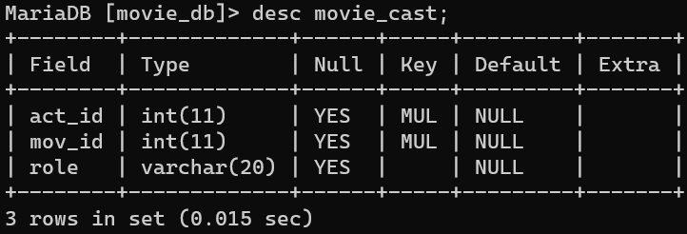

MariaDB [movie_db]> insert into movie_cast values(101,1,"LEAD ACTOR"),

-> (102,2,"LEAD ACTOR"),

-> (103,3,"LEAD ACTOR"),

-> (104,4,"LEAD ACTOR"),

-> (105,5,"LEAD ACTOR");

Query OK, 5 rows affected (0.003 sec)

Records: 5 Duplicates: 0 Warnings: 0

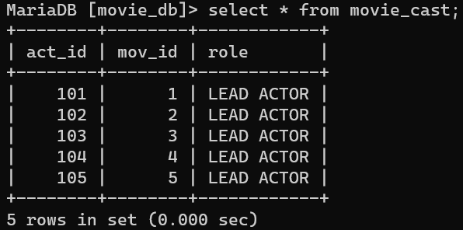

MariaDB [movie_db]> create table director (dir_id int primary key auto_increment,dir_fname varchar(20) not null,dir_lname varchar(20));

Query OK, 0 rows affected (0.011 sec)

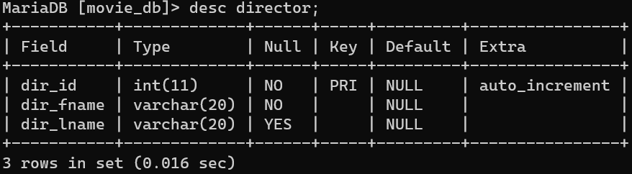

MariaDB [movie_db]> insert into director values(1001,"ASHUTOSH","GOWARIKER"),

-> (1002,"RAJKUMAR","HIRANI"),

-> (1003,"RIDLEY","SCOTT"),

-> (1004,"CHRISTOPHER","McQUARRIE"),

-> (1005,"RISHAB","SHETTY");

Query OK, 5 rows affected (0.004 sec)

Records: 5 Duplicates: 0 Warnings: 0

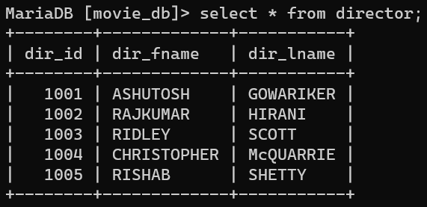

MariaDB [movie_db]> create table movie_direction(dir_id int primary key auto_increment,mov_id int not null,

-> foreign key(dir_id) references director(dir_id),

-> foreign key(mov_id) references movie(mov_id));

Query OK, 0 rows affected (0.034 sec)

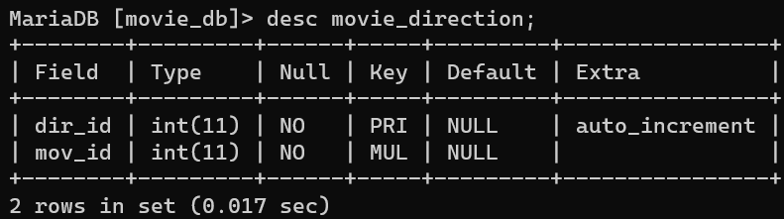

MariaDB [movie_db]> insert into movie_direction values(1001,1),(1002,2)

,(1003,3),(1004,4),(1005,5);

Query OK, 5 rows affected (0.005 sec)

Records: 5 Duplicates: 0 Warnings: 0

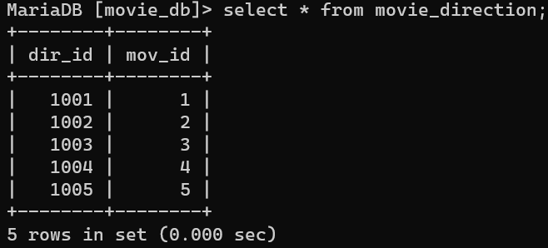

MariaDB [movie_db]> create table genres(gen_id int primary key auto_inc

rement,gen_title varchar(20) not null);

Query OK, 0 rows affected (0.011 sec)

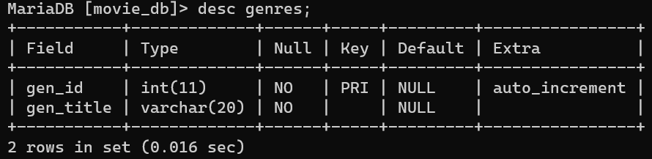

MariaDB [movie_db]> insert into genres values(501,"DRAMA+MUSICAL"),

-> (502,"COMEDY+DRAMA"),

-> (503,"SCI-FIC+ADVEN.+DRAMA"),

-> (504,"ACTION+ADVEN.+THRILL"),

-> (505,"ACTION+ADVEN.+DRAMA");

Query OK, 5 rows affected (0.024 sec)

Records: 5 Duplicates: 0 Warnings: 0

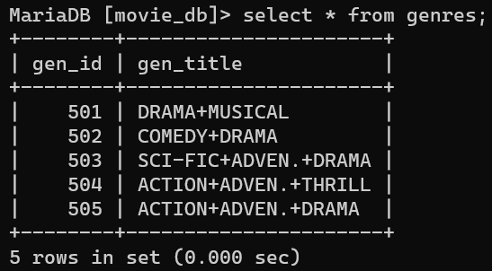

MariaDB [movie_db]> create table movie_genres(mov_id int primary key auto_increment,gen_id int not null,

-> foreign key(mov_id) references movie(mov_id),

-> foreign key(gen_id) references genres(gen_id));

Query OK, 0 rows affected (0.033 sec)

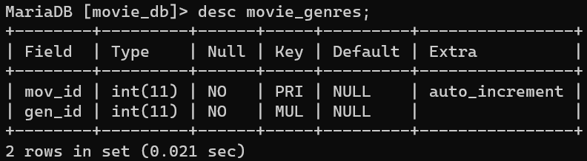

MariaDB [movie_db]> insert into movie_genres values(1,501),(2,502),(3,5

03),(4,504),(5,505);

Query OK, 5 rows affected (0.003 sec)

Records: 5 Duplicates: 0 Warnings: 0

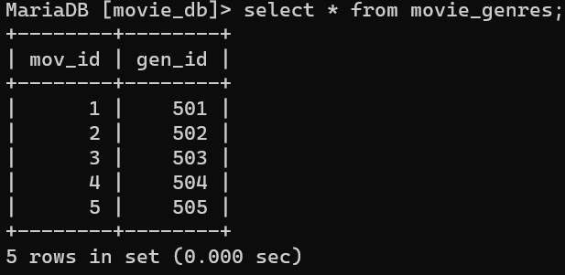

MariaDB [movie_db]> create table reviewer(rev_id int primary key auto_i

ncrement,rev_name varchar(20) not null);

Query OK, 0 rows affected (0.036 sec)

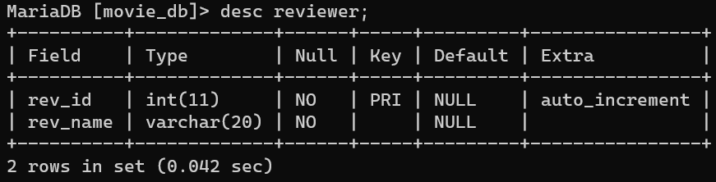

MariaDB [movie_db]> insert into reviewer values (201,"AJAY MEHRA"),(202,"ANKITA SHAH"),(203,"MANISHA MOITRA"),(204,"NADEEM KHAN"),(205,"TARAN

ADARSH");

Query OK, 5 rows affected (0.004 sec)

Records: 5 Duplicates: 0 Warnings: 0

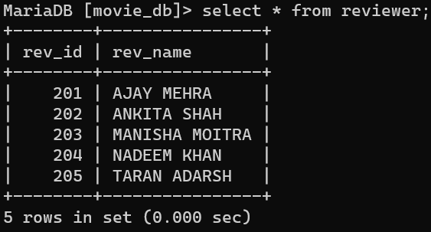

MariaDB [movie_db]> create table rating (mov_id int primary key auto_increment,rev_id int not null,rev_stars varchar(10),num_o_ratings int,

-> foreign key(mov_id) references movie(mov_id),

-> foreign key(rev_id) references reviewer(rev_id));

Query OK, 0 rows affected (0.025 sec)

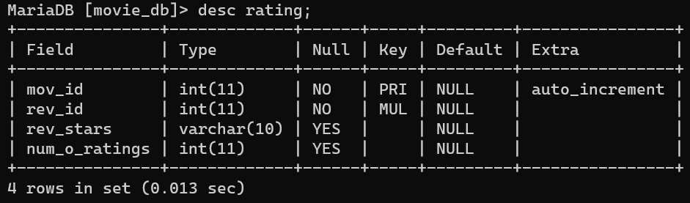

MariaDB [movie_db]> insert into rating values(1,201,"*****",1),

-> (2,202,"****",1),

-> (3,203,"****",1),

-> (4,204,"***",1),

-> (5,205,"****",1);

Query OK, 5 rows affected (0.003 sec)

Records: 5 Duplicates: 0 Warnings: 0

